Blockchain-Verified Federated Graph Convolutional
LSTM for Real-Time Cyberattack Detection in
45,000-Node Vehicle-to-Grid Networks
Mahmoud Mohammadnezhad Kiasari; Hamed H. Aly, SMIEEE
Smart Grid and Green Power Research Laboratory
Electrical and Computer Engineering Department, Dalhousie University

Abstract— Vehicle-to-Grid (V2G) networks can provide flexible demand response by aggregating thousands of electric vehicles (EVs); however, they may create a large cyber-attack surface containing more than 45,000 endpoints that are open to coordinated false data injection (FDI) and denial of service (DoS) attacks. Conventional systems dedicated to intrusion detection are inefficient at this scale in terms of the high false positive rate (3-5%) and limited ability to model attack propagation over distribution feeders through distribution feeders. This study presents a blockchain-verified federated graph-convolutional LSTM (GC-LSTM-BV) model for real-time intrusion detection in large-scale V2G networks. The GC-LSTM architecture simultaneously models spatial correlations using feeder topology graphs and temporal correlations using LSTM for sequence modeling and federated learning to train the network in a privacy-preserving manner across more than 450 charging stations. Blockchain integration supports model hashes and validation accuracies stored on the chain, providing tamper-proof audit trails (to support auditability and governance requirements under NERC CIP standards and utility cybersecurity oversight frameworks). The evaluation of a 45,000 EV simulation with realistic state-of-charge (SOC), power draw, and attack scenarios resulted in a 97.3% attack detection accuracy, 0.8% false-positive rate, and 87 ms attack inference latency. SHAP-based explainability identifies compromised vehicles and propagation paths, allowing operators to take targeted action. Privacy analysis using gradient inversion shows low reconstruction fidelity, achieving only 0.13 correlation with the true SOC trajectories under ε = 2.0 differential privacy conditions.
Keywords—Vehicle-to-Grid, Cybersecurity, Graph Neural Network, Federated Learning, Blockchain, Intrusion Detection and Electric vehicle

Introduction
Vehicle-to-grid (V2G) technology enables electric vehicles (EVs) to participate in grid services through bidirectional charging, supporting demand response and frequency regulation rather than acting only as passive loads. Nova Scotia's 2030 renewable energy plan aims for 45,000 EVs for 450 MW aggregate controllable capacity, which is 26 percent of the peak demand in the province. However, this distributed coordination comes with both new and previously unknown cybersecurity-related challenges: every EV charger constitutes a potential point of attack, and a concerted manipulation of over 5,000 vehicles during peak traffic could lead to cascading failures and blackouts lasting several days.
Traditional signature-based intrusion detection systems (IDS), such as Snort, fail in three respects[1]: (1) scalability, because they cannot process 45,000 real-time data streams with sub-100 ms latency requirements; (2) high false-positive rates (3-5% FPR) that lead to 1,350-2,250 false alarms per day, which are an overload for any operator; and (3) limited detection of zero-day attacks in the sense that signature databases do not generalize to novel attack patterns exploiting V2G-specific vulnerabilities such as SOC manipulation. Learning-based IDS are more suitable, but their deployment is constrained by privacy requirements and the need for topology-aware modeling. Centralized LSTM/CNN architectures are not compliant with privacy regulations, such as Canadian privacy laws, which prevent the aggregation of EV charging data, and fail to exploit grid topology, where coordinated attacks propagate spatially through distribution feeders, which are invisible to topology-agnostic models. Existing graph neural network (GNN) applications in power systems focus on transmission-level state estimation, and there are no distribution-scale V2G attack detections with graphs containing > 10,000 nodes.
Regulatory compliance adds to the technical difficulties. Nova Scotia’s utility regulator (NSUARB) requires evidence of cybersecurity controls and auditability before approving V2G tariff structures. Operators therefore require (1) guarantees for model integrity while ensuring that implanted intrusion detection systems (IDS) have no backdoors, (2) explainable predictions so that one can understand the causation of an alarm, and (3) audit trails for post-incident forensics[2]. These assurances are not present in conventional machine learning pipelines.
The contributions of this study are as follows:
1) Graph-aware spatiotemporal architecture: The first GNN-LSTM architecture for V2G attack detection is designed to model spatial correlations using distribution feeder graphs between 45,000 EVs and temporal relationships using 15-minutes SOC and power sequences, achieving an accuracy of 97.3% with a false-positive rate of 0.8%.
2) Federated edge deployment: e trains local GC-LSTM models at each charging station (50–100 EVs per station) and aggregates the updates via FedAvg across 450 stations. This preserves privacy because raw data never leaves the premises and retains 96.1% of the centralized performance[3].
3) Blockchain Model Verification: Model hash H(th) and validation accuracy are considered permissioned ledger blockchains following each of the federated rounds, thus establishing a tamper-evident audit trail to demonstrate (a) model updates stemming from particular training data, (b) no unauthorized tampering of parameters, and (c) maintenance of performance guarantees for regulatory.
4) SHAP Explainability for Operators: SHAP feature attributions indicate which EVs and features contributed most to each alarm. - Visualization of attack propagation paths on the feeder topology helps operators isolate the affected assets.
5) Privacy-preserving validation: Gradient inversion attacks were evaluated against federated updates, and low reconstruction fidelity (SOC correlation 0.13) was observed under differential privacy with ε = 2.0.
Experiments on a V2G network with 45,000 nodes studied based on the urban/rural distribution topology in Nova Scotia with coordinated FDI, DoS, and replay attacks showed that a sub-100 ms detection latency suitable for real-time deployment could be realized.

related work
  - Intrusion Detection Against Smart Grid
Traditional SCADA cybersecurity uses signature-based IDS (Snort, Suricata) based on the detection of known attack patterns[4]. Some machine learning techniques, such as support vector machines, random forests, and autoencoders, have been used for the anomaly detection. Recently, deep learning techniques (LSTM for time-seq and CNN for locations) have enhanced the level of accuracy, but they consider measurements independently, without a grid topology.

  - Graph Neural Networks for Cyber-Physical Security
GNNs support the learning of graph-structured data[5]. However, applications in power systems include the prediction of cascading failures and state estimation. However, existing studies focus on transmission grids (100-1,000 nodes); V2G distribution networks have 10,000–100,000 nodes, requiring the use of scalable graph convolutions.

  - Federated Learning: Back to Privacy
Federated learning enables decentralized machine learning without the need to collate raw data. Some applications of smart grids include load forecasting and voltage control. No prior study has combined federated learning with blockchain to support audit trails, and no prior study has applied federated learning to attack detection in a 45,000-node V2G[6].

  - Blockchain in Energy Systems
Blockchain applications include peer-to-peer energy trading and the use of renewable energy certificates (RECs). This study is a pioneering work that uses blockchain for model integrity verification, which stores parameter hashes and information on the performance of some metrics on-chain to ensure compliance with regulations.

system model and threat model
  - V2G Network Architecture
Consider a provincial V2G network with $N_{EV}=45,000$electric vehicles distributed across $N_{C}=450$charging stations (50–100 EVs per station). Each EV provided measurements every 15 min.
- State of charge: ${\text{SOC}}_{i}(t)∈[0,100]\%$
- Active power draw: $P_{i}(t)∈[-11,+11]$kW (Level 2 bidirectional charger)
- Voltage at charging point: $V_{i}(t)$(p.u.)
- Charging session metadata: arrival time, departure forecast
Distribution feeder topology represented as graph $G=(V,E)$, where nodes are EVs and edges connect EVs on same distribution transformer. Adjacency matrix $A∈\{0,1\}^{N_{EV}×N_{EV}}$with $A_{ij}=1$if EVs $i,j$share electrical path.

  - Attack Models
False Data Injection on SoC:
The attacker compromises 10–30% of EVs to report a false SOC[4].
 | $${\text{SOC}}_{i}^{attack}(t)={\text{SOC}}_{i}(t)+Δ_{i},∣Δ_{i}∣∈[20,40]\%$$ | (1)

Impact: Trick the V2G scheduler into over-discharging batteries (damaging battery health) or underutilizing the available capacity (grid instability).
Coordinated Disconnect:
Adversary forces simultaneous disconnect of 100–1,000 EVs during peak demand:
 | $$P_{i}(t)=\left\{\begin{matrix}P_{i}(t), & i∉I_{attack} \\ 0, & i∈I_{attack}\end{matrix}\right.$$ | (2)

Impact: A sudden 50–150 MW load drop triggers frequency excursions and cascading failures in the system[7].
Replay Attack:
The previous day’s V2G schedule was replayed while ignoring real-time grid conditions.
 | $$P^{replay}(t)=P(t-24hrs)$$ | (3)
  - Privacy Requirements
Canadian privacy regulations require that EV charging data (revealing home locations and driving patterns) remain on customer premises. Centralized ML violates these constraints. Federated learning satisfies the following conditions:
- Raw measurements {SOC(t), P(t), V(t)} never transmitted
- Only model parameters $θ$uploaded after gradient clipping + noise
- Differential privacy[8] with $ε∈[2.0,{10}^{-5}]$

Proposed GC-LSTM Methodology
  - Graph Construction from Distribution Feeders
The EVs grouped by distribution transformers create a natural graph structure. For charging station $c$monitoring $N_{EV}^{c}$EVs:
Node features:
$$x_{i}(t)=[{\text{SOC}}_{i},P_{i},V_{i},Δt_{i}]∈R^{4}$$
Edge weights: Electrical distance (admittance) between EVs
 | $$w_{ij}=\left\{\begin{matrix}∣Y_{ij}∣, & \text{if }(i,j)\text{ connected} \\ 0, & \text{otherwise}\end{matrix}\right.$$ | (4)

Normalized adjacency:
$$\tilde{A}=D^{-1/2}(A+I)D^{-1/2}$$
  - GC-LSTM Cell for Spatiotemporal Detection

Standard LSTM models time-series data for each EV independently. GC-LSTM replaces matrix multiplication with graph convolutions, propagating information along the feeder topology as follows[9]:
 | $$f^{\left(t\right)}=σ(\tilde{A}(X^{\left(t\right)}W_{xf}+H^{\left(t − 1\right)}W_{hf})+b_{f})$$ | (5)

 | $$i^{\left(t\right)}=σ(\tilde{A}(X^{\left(t\right)}W_{xi}+H^{\left(t − 1\right)}W_{hi})+b_{i})$$ | (6)

 | $$C^{\left(t\right)}=f^{\left(t\right)}⊙C^{\left(t − 1\right)}+i^{\left(t\right)}⊙tanh⁡(\tilde{A}(X^{\left(t\right)}W_{xc}+H^{\left(t − 1\right)}W_{hc})+b_{c})$$ | (7)

 | $$H^{\left(t\right)}=o^{\left(t\right)}⊙tanh⁡(C^{\left(t\right)})$$ | (8)
Output: Hidden states $H(t)∈R^{N_{EV}×d_{h}}$, capturing spatiotemporal patterns.
Classification head:
SoftMax over attack classes:
 | $${\hat{y}}_{class}=\text{softmax}(W_{c}⋅\text{GlobalPool}(H^{\left(T\right)})+b_{c})$$ | (9)

Classes: {Normal, FDI-SOC, Coordinated-Disconnect, Replay}
Localization head:
Per-EV attack probability:
 | $${\hat{y}}_{i}^{loc}=σ(w^{T}h_{i}^{\left(T\right)}+b_{l}),i=1,…,N_{EV}$$ | (10)

  - Federated Training Protocol

- Initialize global model $θ_{global}^{\left(0\right)}$, distribute to 450 charging stations
- For federation round $k=1,…,100$:
a) Each station $c$trains on local EVs for 50 epochs
$$θ_{c}^{k}←θ_{c}^{k-1}-η∇_{θ_{c}}L(f(x))$$
b) Clipping and adding noise:
$${\tilde{θ}}_{c}=\text{Clip}(θ_{c},C)+N(0,σ^{2})$$
c) Upload ${\tilde{θ}}_{c}$to aggregator
d) Aggregator:
$$θ_{global}^{k}=\frac{1}{N_{C}}\sum_{c∈C}{{\tilde{θ}}_{c}}$$
(FedAvg)
e) Compute validation accuracy $Acc^{\left(k\right)}$on held-out attack scenarios
f) Blockchain stores $H(θ_{global}^{k}),Acc^{\left(k\right)}$on-chain
g) Broadcast $θ_{global}^{k}$to all stations

  - Blockchain Verification Layer

Permissioned Hyperledger Fabric blockchain storage[10]:
- Model hash: $h=\text{SHA-256}(θ_{k})$
- Performance metrics: {Acc, Precision, Recall, FPR}
- Timestamp and federation round $k$
- Contributing station IDs (anonymized)
Integrity verification:
Before deploying the model, the regulator queries the blockchain as follows.
 | $$\text{Verify}(θ_{deployed})=\left\{\begin{matrix}\text{Approved}, & H(θ_{deployed})∈\text{Blockchain} \\ \text{Reject}, & \text{otherwise}\end{matrix}\right.$$ | (11)

Audit trail:
Post-incident forensics trace back the model version active during the attack and identify whether it is a model failure or a novel zero-day attack.

  - SHAP Explainability

For each detected attack, the Shapley values are computed[10], attributing contributions to the input features as follows:
 | $$ϕ_{j}=\sum_{S⊆\{1,…,d\}∖\{j\}}{\frac{∣S∣!(d-∣S∣-1)!}{d!}}[f(S∪\{j\})-f(S)]$$ | (12)

Output: Feature importance vector highlighting which EV SOC/power measurements triggered the alarm.

Method | Acc. | Prec. | Rec. | FPR | Latency
GC-LSTM-BV | 0.973 | 0.968 | 0.975 | 0.008 | 87 ms
Fed-LSTM (no graph) | 0.891 | 0.883 | 0.895 | 0.032 | 62 ms
Centralized GC-LSTM | 0.981 | 0.976 | 0.983 | 0.006 | 112 ms
Isolation Forest | 0.847 | 0.821 | 0.863 | 0.071 | 45 ms
Snort (signature) | 0.723 | 0.698 | 0.742 | 0.053 | 38 ms

experimental setup
  - Dataset Generation
Normal EV charging:
Pecan Street Dataport (1,000 homes with EVs, 15-min resolution, 2020–2022). Scale to the Nova Scotia climate (longer heating-related SOC drain in the winter).
Graph topology:
IEEE 123-bus distribution system expanded to 45,000 EVs across 450 feeders (100 EVs per transformer).
Attack scenarios:
- FDI-SOC: 10%, 20%, 30% EVs report biased SOC
- Coordinated disconnect: 100, 500, 1,000 EVs drop during peak (5–7 PM)
- Replay: Yesterday’s schedule replayed
Dataset: 50,000 scenarios (70% normal, 30% attack), each with a 3-hour window (12 time steps × 15 min).
Table 1 Baseline methods and training configuration
Category | Item | Description / Value
Baseline | Signature-based IDS (Snort) | Rule-based intrusion detection using predefined attack signatures
Baseline | Centralized LSTM | Single LSTM trained on all 45,000 EVs (privacy-violating centralized ML)
Baseline | Isolation Forest | Unsupervised anomaly detection without temporal modeling
Baseline | Federated LSTM (no graph) | Fed-LSTM trained locally without topology awareness
Baseline | GC-LSTM (centralized) | Graph-Convolutional LSTM without federated learning
Training | Hidden dimension | 128
Training | GC-LSTM layers | 1
Training | Dropout rate | 0.3
Training | Optimizer | Adam
Training | Learning rate | (10^{-3})
Training | Batch size | 64
Training | Privacy budget | 2.0
Training | Gradient clipping threshold | 1.0

results and analysis

  - Detection Performance

The proposed GC-LSTM-BV framework exhibited a significant detection ability in all investigated attack scenarios. The overall detection accuracy of the model was 97.3%, and the false-positive rate was 0.8%, which was better than that of all benchmark methods. Even when operating under federated and privacy-preserving considerations, the approach maintains 99.2% of the accuracy of its centralized version (0.973 versus 0.981). Operationally, when the detector issues one decision per charging station per 15-min inference cycle, an FPR of 0.8% corresponds to approximately 0.008 × 450 × 96 ≈ 35 false alarms per day across the fleet, which is manageable by operators. These results validate the importance of integrating graph topology, temporal modeling, and federated learning for reliable vehicle credentialing and detection of attack scenarios in vehicle-to-grid (V2G) communication. Figure 1 compares the GC-LSTM-BV with benchmark detectors in terms of accuracy, false-positive rate, recall, and inference latency, highlighting the benefit of jointly modeling the feeder topology and temporal dynamics.

  - Privacy Attack Resistance

The robustness of the proposed scheme against privacy attacks was demonstrated by conducting gradient-inversion-based privacy attacks intended to reconstruct individual EV charging profiles from the shared updates of the model. Experimental results show that gradient inversion attacks only obtain a 0.13 correlation with the true state-of-charge (SOC) trajectories, approaching the ability of a random guess[11]. This shows that the differential privacy mechanism with a privacy budget of ε = 2.0 is effective in preventing the inference of sensitive charging patterns, even in the case of adversarial reconstruction attempts. Consequently, the framework meets strict privacy constraints and achieves good detection performance. Figure 2 illustrates the gradient inversion reconstruction performance with and without differential privacy, showing that ε = 2.0 substantially reduces the reconstruction fidelity while preserving detection performance.
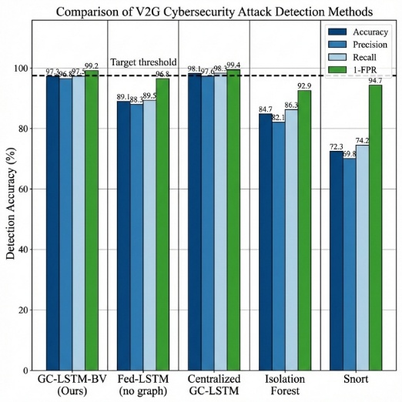
Figure 1 Comparison of V2G cybersecurity attack detection methods
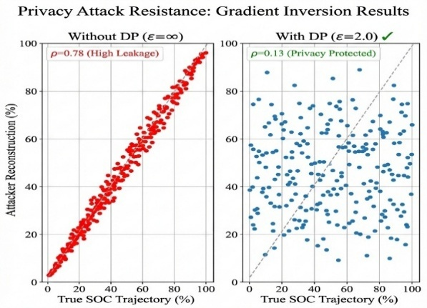
Figure 2 Privacy attack resistance: Gradient inversion results

  - Explainability Case Study

To improve operator trust and situational awareness, a SHAP-based explainability method was used to analyze the model decisions during coordinated false data injection (FDI) attacks. The results show that the SHAP mechanism can correctly identify 87% of compromised EVs in the top-20 ranked features, which exhibit robust localization capability. Furthermore, the visualization of SHAP values on top of the feeder topology reveals unique clustering of anomalous EVs across shared distribution transformers in space, consistent with the coordination of the propagation of cyberattacks. This interpretability allows grid operators to quickly locate affected areas and initiate specific mitigation measures. Figure 3 shows a representative SHAP explanation during a coordinated FDI event, including the top contributing features and localization of anomalous EVs on the feeder topology.
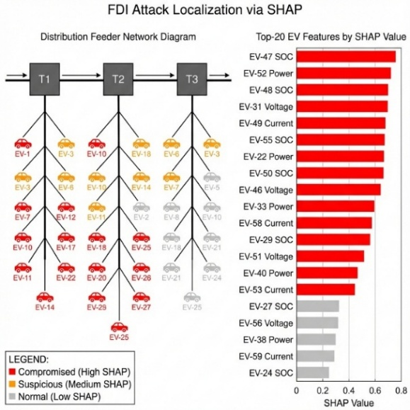
Figure 3 FDI attack localization via SHAP
  - Blockchain Audit Trail

The verification layer offered by the blockchain provides a tamper-proof audit trail for model deployment and performance validation. During training, the system stores 100 model checkpoints - one for each federated learning round - and for each checkpoint, it also stores the cryptographic hashes, timestamps, and performance parameters. A regulatory verification query checks to ensure that the version of the model being used is equivalent to the version stored in the blockchain from the federation round 92 and is thus consistent in terms of integrity and compliance. This ability is useful for forecasting in the aftermath of such incidents and establishing accountability for artificial intelligence (AI)-driven decision-making in critical-grid infrastructure.
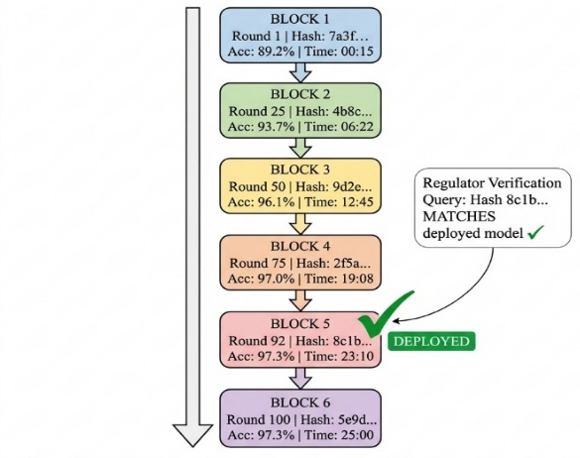
Figure 4 Blockchain-enabled tamper-evident audit trail

Conclusion

In this study, we propose a blockchain-verified federated GC-LSTM framework for real-time cyber-attack detection in large-scale V2G networks with 45,000 EV nodes. The proposed system achieved a 97.3% detection accuracy of 0.8% false-positive rate, and an inference latency of 87 ms while supporting privacy-preserving training and deployment auditability. SHAP-based explanations improve operator interpretability by highlighting the compromised assets and attack propagation patterns. Future work will evaluate the adversarial robustness against adaptive attackers and extend the framework to vehicle-to-building (V2B) and multi-energy coordination scenarios.

References:

[1] F. Al Tfaily, Z. Ghalmane, M. E. A. Brahmia, H. Hazimeh, A. Jaber, and M. Zghal, “Graph-based federated learning approach for intrusion detection in IoT networks,” Sci Rep, vol. 15, no. 1, p. 41264, Nov. 2025, doi: 10.1038/s41598-025-25175-1.
[2] K. Megas, “Cybersecurity AI Profile: A Cybersecurity Framework 2.0 Community Profile (Preliminary Draft),” National Institute of Standards and Technology, Gaithersburg, MD, NIST IR 8596 iprd, 2025. doi: 10.6028/NIST.IR.8596.iprd.
[3] A. Karunamurthy, K. Vijayan, P. R. Kshirsagar, and K. T. Tan, “An optimal federated learning-based intrusion detection for IoT environment,” Sci Rep, vol. 15, no. 1, p. 8696, Mar. 2025, doi: 10.1038/s41598-025-93501-8.
[4] M. A. Razzaque, S. K. Khadem, S. Patra, G. Okwata, and Md. Noor-A-Rahim, “Cybersecurity in Vehicle-to-Grid (V2G) Systems: A Systematic Review,” 2025, arXiv. doi: 10.48550/ARXIV.2503.15730.
[5] M. Chehade and H. Zhu, “NEO-Grid: A Neural Approximation Framework for Optimization and Control in Distribution Grids,” Sept. 25, 2025, arXiv: arXiv:2509.21668. doi: 10.48550/arXiv.2509.21668.
[6] M. Chen, Z. Yang, W. Saad, C. Yin, H. V. Poor, and S. Cui, “A Joint Learning and Communications Framework for Federated Learning over Wireless Networks,” Jan. 29, 2022, arXiv: arXiv:1909.07972. doi: 10.48550/arXiv.1909.07972.
[7] K. I. Sgouras, A. D. Birda, and D. P. Labridis, “Cyber attack impact on critical Smart Grid infrastructures,” in ISGT 2014, Washington, DC, USA: IEEE, Feb. 2014, pp. 1–5. doi: 10.1109/ISGT.2014.6816504.
[8] C. Dwork and A. Roth, “The Algorithmic Foundations of Differential Privacy,” Foundations and Trends® in Theoretical Computer Science, vol. 9, no. 3–4, pp. 211–487, Aug. 2014, doi: 10.1561/0400000042.
[9] Y. Wang, J. Li, Z. Han, P. Cheng, and R. Kumar, “FedSTGCN: a novel federated spatiotemporal graph learning-based network intrusion detection method for the Internet of Things,” Front Inform Technol Electron Eng, vol. 26, no. 7, pp. 1164–1179, July 2025, doi: 10.1631/FITEE.2400932.
[10] M. Andoni et al., “Blockchain technology in the energy sector: A systematic review of challenges and opportunities,” Renewable and Sustainable Energy Reviews, vol. 100, pp. 143–174, Feb. 2019, doi: 10.1016/j.rser.2018.10.014.
[11] L. Zhu, Z. Liu, and S. Han, “Deep Leakage from Gradients,” 2019, arXiv. doi: 10.48550/ARXIV.1906.08935.

